BAMFORD CHAPEL & NORDEN URC – Sunday 21st February 2021 – First Sunday in Lent
Worship compiled by Ian Royle (Shaw & Heyside URC)

Hello, everyone. I have only once led worship at Bamford Chapel and that was 20 years ago so I am very sorry that I cannot be with you this morning and unfortunately, neither am I able to offer you a video version of the service. Though we all do our best, there are bound to be limitations in presentations of this kind but there are also opportunities to try something a bit different. So I hope that you find the study of Holman Hunt’s painting and the “Meditation in Stones” thought provoking and perhaps even helpful for this First Sunday in Lent

Call to Worship: Forty days and forty nights; Jesus fasting in the wild.
Forty days and forty nights; tempted still yet undefiled.

First Hymn: Please join in. You are still allowed to sing in your own homes
1. Lead us, heavenly Father, lead us 2. Saviour, breathe, forgiveness o’er us;
o’er the world’s tempestuous sea; all our weakness thou dost know,
guard us, guide us, keep us, feed us, thou didst tread this earth before us,
for we have no help but thee; thou didst feel its keenest woe;
yet possessing every blessing lone and dreary, faint and weary,
if our God our Father be. Through the desert thou didst go.

3. Spirit of our God, descending,
fill our hearts with heavenly joy,
love with every passion blending,
pleasure that can never cloy;
thus provided pardoned guided,
nothing can our peace destroy
James Edmeston ccli 169737 Streaming Licence 595811

Prayers for “Going Forward” at this difficult time
Almighty God, you are great and greatly to be praised.
Awaken us so that we delight in your praises.
You made us for yourself but our hearts remain restless
until they find their peace in you

You are the God who sometimes chooses
the weak things of the world to confound the mighty.
Guide us, that our lips may praise you and our lives please you
even as our thoughts and prayers continuously glorify you.

God of our lives, there have been so many days in the past year
when we have floundered helplessly with forces beyond our control;
so many days when the road ahead seemed endless and uncertain
when darkness prevailed and light seemed but a distant glimmer

Yet in the gloom and sadness we have learned to see the world afresh
as quiet resignation replaced the hectic bustle of “normality”.
Enriched by both the pain and the new simplicity of our being
Pity and kindness have seemed closer to our everyday existence.

Now, sensing that the long night of isolation and restraint may soon be over.
we turn our hearts to you once more: our weary sadness mixed with hope
of loved ones we may again embrace and joys returning to our lives;
cherishing still the gentle kindness and loving dedication we have seen.

The summer of our souls lies ahead but first the triumph of Easter beckons.
As we prepare ourselves for Christ’s Passion in our Lenten thoughts,
help us to reflect and pray for this battered and bewildered world
by contemplating the struggles of our Lord Jesus Christ

As we turn our thoughts to Jesus in the Wilderness,
may we too resolve to stand firm against the temptations of the evil one;
searching our souls for the truth and wisdom of your guidance,
determined to learn from past mistakes as we build a “new normality”.

Help us to see the folly in our ways and resolve to be better people than before;
less driven by the pursuit of material things and more ready to share;
seeking to control ourselves rather than those around us,
willing to learn, ready to teach and steady in love.

Lord refresh us, we pray as we aim to renew our society.
May life grow sweeter for those who are confused by it,
Happier for those who have tasted the bitterness of it,
Safer for those terrified by the peril of it,

May it prove more friendly for those isolated in loneliness by it,
Serener for those who toiled in the thick of it,
Holier for all those for whom life has lost all dignity, beauty and meaning.
We ask this in the name of Jesus, our Christ, who taught us to pray saying……..

The Lord’s Prayer

Old Testament Reading: Exodus 17 vv 1 -7 Dry rocks in a desert
From the wilderness of Sin the congregation of the Israelites journeyed by stages, as the LORD commanded. They camped at Rephidim, but there was no water for the people to drink. The people quarrelled with Moses, and said, "Give us water to drink." Moses said to them, "Why do you quarrel with me? Why do you test the LORD?" But the people thirsted for water; and the people complained against Moses and said, "Why did you bring us out of Egypt, to kill us, our children and livestock with thirst?

So Moses cried out to the LORD, "What shall I do? They are ready to stone me." The LORD said to Moses, "Go on ahead of the people, and take some of the elders of Israel with you; take in your hand your staff with and go. I will be standing there in front of you on the rock at Horeb. Strike the rock, and water will come out of it, so that the people may drink." Moses did so, and he called the place Massah and Meribah, because the Israelites quarrelled and tested the LORD, saying, "Is the LORD among us or not?"

Second Hymn Behold a little child
Laid in a manger bed;
The wintry blasts blow wild
Around his infant head.
But who is this, so lowly laid?
The Lord by whom the worlds were made.

The hands that all things made Christ, Master Carpenter
An earthly craft pursue; we come rough-hewn to thee;
Where Joseph plies his trade, at last, through wood and nails,
There Jesus labours too, thou mad’st us whole and free.
That weary ones in him may rest, In this thy world remake us, planned
And faithful toil through him be blest. to truer beauty of thine hand

Caryl Micklem ccli 169737 Streaming Licence 595811

Does every picture tell a story? The painting below from Manchester Art Gallery is by the Pre-Raphaelite artist, William Holman Hunt who was a devoted Christian. The picture really speaks for itself so all I am going to do today is ask you a few questions about it.

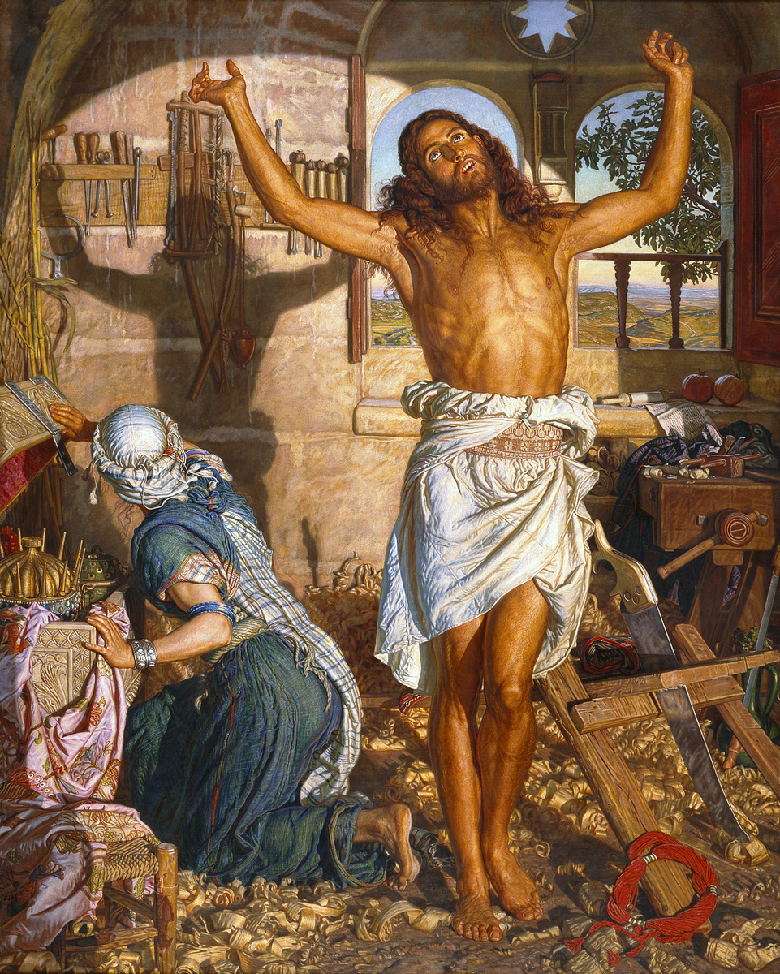
- Who does the picture portray?
- What makes you say that?
- Who is the lady in the picture?
- Where are they?
- What is in the box?
- What is on the wall behind the man?
- What incident does it remind us of?
- What does the window behind the man’s head bring to mind?
- What does the star window remind you of?
- What does the hank of red wool suggest?
- What does the tool pointing to the man’s left side indicate?
- If you had to give this picture a title, what would it be?
(Don’t look yet, but I give the answers after the blessing.)

New Testament Reading: Matthew 4 vv 1 -11 Stones in the wilderness
Then Jesus was led up by the Spirit into the wilderness to be tempted by the devil.
He fasted forty days and forty nights, and afterwards he was famished. The tempter came and said to him, "If you are the Son of God, command these stones to become loaves of bread." But he answered, "It is written, 'One does not live by bread alone, but by every word that comes from the mouth of God.' "Then the devil took him to the holy city and placed him on the pinnacle of the temple, saying to him, "If you are the Son of God, throw yourself down; for it is written, 'He will command his angels concerning you,' and 'On their hands they will bear you up, so that you will not dash your foot against a stone." Jesus said to him, "Again it is written, 'Do not put the Lord your God to the test.'" Again, the devil took him to a very high mountain and showed him all the kingdoms of the world and their splendour; and he said to him, "All these I will give you, if you will fall down and worship me." Jesus said to him, "Away with you, Satan! for it is written, 'Worship the Lord your God, and serve only him”. Then the devil left him, and the angels came and waited on him.
Third Hymn
1. When we are tested and wrestle alone, 3. When we are tempted to barter our souls
longing for bread when world offers stone, trading the truth for the power to control
nourish us, God, by your word and your way, teach us to worship and praise only you
food that sustains us by night and by day seeking your will in the work that we do.

2.When in the desert we cry for relief, 4. When we’ve struggled and searched in the night
pleading for paths marked by certain belief, sorting and sifting the wrong from the right,
lift us to love you beyond sign and test, Saviour surround us with circles of care,
trusting your presence, our only true rest. Angels of healing, of hope, and of prayer.

Ruth C Duck Hope Publishing Company ccli 169737 Streaming Licence 595811

Sermon: “Temptations for technocrats”
Had I been younger I might have been tempted by the leaflet through my letterbox :
“There’s never been a better time to re-train as a plumber. Would you like to be your own boss? Do you want to be home based? Realise your full potential. You could be one of thousands of plumbers that are so much in demand……..”

We all know the situation. You can never find the right tradesman when you need one. Folk aim for prestige jobs and somewhere along the line your handy plumber decides that he would be better off as a heating engineer.

It was not always like that. When I came to teach at Rochdale Technical College almost 60 years ago about 500 students passed through my classes each week: Plumbers, Joiners, Bricklayers, Electricians, Engineers, Fitters, Welders, and Springmakers. These people with a pride in their trade showed deference to those of higher status and disdain to those below. Technicians were not as good as Technologists but thought themselves superior to mere craftsmen. Electricians rivalled Engineers. Brickies respected Joiners but mocked Plumbers. Commerce in those days was mainly for girls, “the delicate” or the offspring of the boss!

How did I come to be part of all this? My Bricklayer Dad used to say, “Look Son, you don’t want hands like these; you stick to your books.” So I did and acquired enough “fancy college ways” to make myself virtually unemployable. Fortunately, the powers-that-be, fearing that there might be “two cultures”, were insisting that technical students should be subjected to a broader education. So I was appointed as a Lecturer in Social and Liberal Studies and filled my days in lively discussion with young people ready to ask challenging questions.

One of their questions, of course, was “How’s all this going to help me in my job?” Little did they realise how the world was about to change for us all. Those old trades declined and almost disappeared from colleges. As my career progressed I moved over to Commerce; such a growth area that every few years the department split like cancer cells or mutated like a virus and proceed to grow again. Commerce became Secretarial Studies + Business: then Business Studies was divided again into Management and Computing.

This merely reflected what was happening in the international economy. UKs manufacturing tradition was in sharp decline and, instead, factories polluted the atmospheres of far distant countries. Yet we did not starve; our economy flourished. Young men in London offices with their eyes on computer screens and ears to mobiles made “loads a money”; enough to pay the plumber if they could find one. It seemed as if we were living out Mark Twain’s joke about making a precarious living by taking in each others washing” Politicians, economists and journalists moralised about what was happening. You have a right to Material things, they said but not to be Greedy or inflationary pressures will undermine our competitiveness. By the same token we have a right to succeed in life – but Ambition has another side. It’s a pity about the pits and mills closing down, of course; they were good for other people to work in – but not for us or our kids. Old type craftsmen were entitled to Pride in what they did but their resistance to change was widely deplored.

You may be wondering why, on the FIRST SUNDAY IN LENT I choose to give a lesson in economic history. I am sure you could have tuned into Andrew Marr for something more topical. So let me turn to the story of another young man who made a career change; giving up his job as a carpenter to re-train for the ministry. His name, of course, was Jesus.

These days someone training for Ministry would follow a structured programme; Greek or Hebrew, Theology, Doctrine and Scriptures, Liturgies and Rituals, Pastoral Studies. A good training would include something on Leadership or Inter-personal skills; even on how to run a church meeting by Zoom or a service on YouTube. For sure, Jesus knew his scripture, as did the Gospel writers & Paul; they went through the academic mill of their time. But the Bible offers us a strange story of how Jesus, having been baptised by John and identified as the Messiah, goes off into the desert to fast for forty days and nights before meeting the Devil. This seems rather like offering a modern theology student a placement in a casino or a lap dancing club.

- At first reading the story of Jesus in the wilderness seems odd
Turning stones into bread sounds like a handy skill for feeding the 5,000
High Mountain - all you see can be yours? We have all had that dream.
Leap from the temple top? Makes you shudder at the thought!

- The temptations of Christ are hardly situations you and I would meet in real life
You know you can’t make bread from stone – except by owning a quarry or selling sculpture
You cannot rule the world – though too many have tried
If you want to jump off buildings – perhaps it is time for counselling

- We are not concerned here with SINS but TEMPTATIONS
Not wrong-doings that lead to punishment or retribution
But overstepping the mark and living with the consequences

- These examples are allegorical : symbols for life with spiritual meaning
- Turning stones into bread Is about Materialism and GREED
We all have to eat and earn our keep; maybe even have a few pleasures and luxuries
Yet there is a fine dividing line between living comfortably and seeking too much So Jesus reminds the Devil that there is more to life than getting & spending

- High Mountain Is about being hell bent with AMBITION
We all want to get on in life, make progress, do well, get a better job
. But is this Ambition to fulfil worthy aims or is it mere self-seeking?
Jesus says “Serve only God” (which usually includes mankind)

- Temple Top Is about Self- Respect growing into PRIDE
God loves us so we should love ourselves….. and others just as much
The problems arise when our inflated self-love becomes arrogance and vanity

- The Devil does not try to persuade Jesus to Murder, Steal, Commit Adultery
This is not about the 10 Commandments - Thou shall or shall not

- The discussion is about areas which are part of human nature
Harmless in small doses - but in excess they become a defiance of God

- They are about walking humbly with our God
The Greeks called it “Hubris”; usurping God’s authority

Though harmony with God and nature is desirable, the trouble is that we are all swept along by the technology of our age. So much of human endeavour is devoted to making our lives more convenient and less uncomfortable than nature intended. Walking is natural but transport is quicker. Fridges free us from seasonal limitations. It is better to pop pills than perish. Who now would dare to describe Covid vaccines as “hubris”?

Yet there is a price to pay for progress. For centuries our technologies have worked for humans and, in the process, damaged the planet. We have drained resources and polluted land, sea and air; believing that somehow nature was resilient enough to mend itself. Now we are warned that the earth is at a tipping point and showing signs of irreparable damage.

I hope you can now see the link with my remarks about the 1960s. The young people I taught, like myself, walked a fine line between the reasonable pursuit of prosperity, success and status and the temptation to greed, ambition and pride. The moral and spiritual dilemma faced by Jesus 2000 years ago still exists

- We all want a good standard of living but ignore the associated temptation to greed
Hard work is a virtue but being a workaholic is folly. We like the fine trappings of life but can stumble into debt acquiring them. We aim to prosper and fail to see the envy we generate. Though we avert our eyes, much of our prosperity is derived from exploitation of others. These are hard truths for nice people to face up to but if we overlook them we become spiritually and emotionally poorer for it. “Man does not live by bread alone”

- We all want respect – but some proudly go to degrading lengths to get it!
What drives the Celebrity Culture? Why is a million hits on social media so valued; even for things that people would be otherwise ashamed of? What is the price of fame? What does it do to people? “All this can be yours, if only you will bow down and worship me”

- Naturally we do want to achieve – We are individually and collectively ambitious
Human achievement has advanced impressively. Things once thought unthinkable are now commonplace and still we gasp at the latest wonders. Yet there is a price in global warming, pollution, depleted resources, urban decay etc. We have tinkered with the earth and its resources… and even with mankind “Do not put God to the test”
& remember this,
when you do get a plumber, he too has his temptations, so Coffee- white with 2 sugars, please!

Fourth Hymn: Seek ye first
1.. Seek ye first the kingdom of God and his righteousness  And all these things shall be added unto you.  Alleluia, Alleluia, Alleluia, Allelu, Alleluia | 2.. Ask and it shall be given unto you, seek and ye shall find, knock and the door shall be opened unto you  Alleluia, Alleluia, Alleluia, Allelu, Alleluia
3.. We shall not live by bread alone but by every word that proceeds from the mouth of the Lord  Alleluia, Alleluia, Alleluia, Allelu, Alleluia | Karen Lafferty © 1972 CCCM Music/Maranatha Music/Universal Music Publishing/Song Solutions Daybreak  Ccli 169737 Streaming Licence 595811

A Meditation with stones.
Had we been meeting in church I would at this point have come round with a bag of pebbles and asked you to select one. As you are at home, why not go into the garden now and find a pebble or small stone. I will wait until you get back.

- Good. Now look at your pebble. How was it formed? Heat we can hardly imagine! Think of the pressure of other rocks pressing upon it in the hot state. Feel its hardness.

- Examine its colour; what does that tell you? Think of how many stones there would be on the beach or quarry where this came from.

- Consider its shape. How did it get like that?. Imagine it in the sea or a river with the steady flow of water passing over it. God’s work over centuries!

Now think of some stones in the scriptures.
Lot’s wife turned into rock salt. Jacob rolling away the stone at a well. The stones on the walls of Jericho or in Solomon’s great temple
Stones used in battle The one that slew Goliath
Stones that stoned sinners or martyred Stephen
“Let he that is without sin, cast the first stone” Millstones round the neck
The stony ground where the seed fell A stone rolled away from a tomb

… And today: Jesus in the stony desert; wrestling with temptation

Is your heart of stone? Surely not but………….
What weighs you down? When did you cast a stone unjustly?
Is there something hard or stubborn about you?
What obstacle stops you from being a better Christian?

Recognise how we all tend to repeat our faults and regard them as our right in this world. Yet each adds to our guilt.

So clutch that stone tightly in your hand and ask God to give you greater strength to sustain you through these difficult times.

A Little Prayer: Lord Jesus, help me to use this Lent in the right way; to grow more like you. Don’t let me give up when I find that following you is difficult. Show me each day what you want me to do for your Kingdom and show me how to live as you want me to live.

We are imperfect people; often blind to our own faults.
We need to be sorry for what we do. We need to ask for forgiveness
God promises that forgiveness will be given if we repent
.
In our first reading today, God brought forth water from the desert rocks
The children of Israel journeyed for 40 years in the wilderness fleeing from slavery in Egypt to a new life in a Promised Land. Throughout this journey, God gave them water to drink and food to eat; sustaining them day by day.

When people have no water, say on a long hike, they can partly ease their thirst by sucking on a pebble. You may have tried it. Just like the rock in the Bible story, water seems to spring from it. See your chosen pebble then as living water for your life to keep you going when life seems dry and unpromising.

Plan how you can tap into God’s clear waters this Lenten season so that you become a better person between now and Easter. Make time for God. Make time for your inner thoughts. Make time for people especially those who need your help. We have heard so much lately about the mantra: Hands, Face, Space. Now turn your hands to doing good, face up to truth and make space for God in your life.

Another Little Prayer: Lord Jesus, in this time in the wilderness, help us to look out for the signs of your love to refresh us and revive us on our journey.

Keep this stone with you throughout Lent. Carry it in your pocket, handbag or briefcase. Or put it on the mantelpiece or by the fireside that others may ask about it. Keep it to remind you of the thoughts we shared today.

By Easter Sunday the lockdown may be over, so bring your stone to church with you. Listen to the story of another stone; far bigger than this one. That stone was rolled away from the tomb because it could not keep Christ from the world. So God can roll away all the obstacles that stand between him and us.

After the service, go out into the fields and, making sure no one is in the way, throw that stone as far as you can. Or, if you prefer, drop it in the stream it came from. Get shut of it; it has done its work in our lives. You will “have lost a stone” but reminded yourself how God intends us to be free from the burden of sin.

Final Prayer Jesus says. “Come unto me all ye that are heavy laden and I will refresh you, for I am gentle and humble at heart; the load with my help is light.”

We have laid our burdens down in the presence of the living Lord
We have been nourished for our journey in the presence of the living God
We have taken on the armour of Christ in your name and for your sake,
O loving, living God. Amen

Fifth & Final Hymn: Father, hear the prayer we offer
1.. Father, hear the prayer we offer;  Not for ease that prayer shall be,  But for strength that we may ever  Live our lives courageously. | 2.. Not for ever in green pastures  Do we ask our way to be;  But the steep and rugged pathway  May we tread rejoicingly.
3.. Be our strength in hours of weakness,  in our wanderings be our guide;  Through endeavor, failure, danger,  Father, be though at our side. | Love Maria Willis (1824-1908)  Ccli 169737 Streaming Licence 595811

Blessing
Answers to questions about the picture:
1. Jesus 2. Reminds us of Jesus on the cross 3. His mother, Mary 4. In Joseph’s carpenter’s shop
5. The gifts from the wise men 6. Shadow 7. The Crucifixion 8. Halo
9. Star of Bethlehem 10. Crown of thorns 11. Spear that pierced his side
12 The given title is “The Shadow of Death” but your title is worth thinking about.

I hope you got a good mark in the test – and resisted the temptation to cheat.
God Bless
Ian

As you go on your Lenten journey
May God the Father strengthen you,
God the Son guide you,
And God the Holy Spirit uphold you,
To the triumph of Easter and the brightness of summer.
Amen

