Dear Friends,

I hope you are keeping well.

Please find enclosed the service script for Sunday 28th February – the service is compiled by Debbie Wood.
I hope you join me in praying for the day when we can meet together for in person worship. I have certainly missed it.

Thanks and God Bless,

Richard

Order of Service Sunday 28th February 2021 (2nd Sunday in Lent)
Service led by Debbie Wood
Welcome and intro to first song
As we gather together to worship God, on this second Sunday in Lent, we ask that we will hear His voice in our hearts and minds and that we will be moved by His Spirit as we focus today on the Transfiguration of Christ. We ask for the will and the strength and the commitment to respond to Him whom we come to serve; that we might be transformed spiritually by our meeting with Him in worship so that we will be ready to go out into the world in His name, spreading the love, glory and hope of the cross. Amen.
Take a moment of stillness and quiet as we open our hearts and minds to engage with our living God. In the words of Psalm 37 verse 7 let us: “Be still before the Lord and wait patiently for him”.
Let us now join together to sing Be Still for the Presence of the Lord.
Song- Be Still For The Presence of the Lord
Be still, for the presence of the Lord,
The holy One, is here;
Come bow before him now
With reverence and fear
In him no sin is found
We stand on holy ground.
Be still, for the presence of the Lord,
The holy One, is here.
Be still, for the glory of the Lord
Is shining all around;
He burns with holy fire,
With splendour he is crowned:
How awesome is the sight
Our radiant king of light!
Be still, for the glory of the Lord
Is shining all around.
Be still, for the power of the Lord
Is moving in this place:
He comes to cleanse and heal,
To minister his grace -
No work too hard for him.
In faith receive from him.
Be still, for the power of the Lord
Is moving in this place.

Prayers of thanksgiving and confession:
Let us come together in prayer as we prepare ourselves to listen to what God asks of each of us through our worship today:
Loving God, today we offer you thanks for sharing the glory of what is to come when we turn to You as we focus on the Transfiguration of your beloved son, Jesus, when You pulled back the veil of heaven and revealed Him in all His majesty. You call upon each one of us to listen to Him and so, in order to open our hearts to His Word, first we confess our sins and ask that You will forgive us for our wrong thoughts, words and actions and show us how our lives may be transfigured by your presence, that the radiance of Jesus would shine through us to the dark places of our world. Amen.
Let us join together now in saying the Lord’s Prayer-
Our Father, who art in heaven, hallowed be thy name; thy kingdom come; thy will be done; on earth as it is in heaven. Give us this day our daily bread. And forgive us our trespasses, as we forgive those who trespass against us. And lead us not into temptation; but deliver us from evil. For thine is the kingdom, the power and the glory, for ever and ever. Amen.

Children’s Address:
Slide 1: Let’s begin by listening to a story told in song about a very special moment in Jesus’ life told from the perspective of John- one of Jesus’ disciples. (Video clip)
Slide 2: In this story about the Transfiguration of Jesus – when Jesus the man was changed to Jesus in all His heavenly glory in front of some of his disciples- God tells the disciples to listen to Jesus. We spend a lot of time in our lives listening. Who do you listen to?
Slide 3: I’m sure you listen to your parents. I’m sure they give you lots of advice on how to behave and help you to grow into the best person you can be.
Slide 4: I’m sure you listen to your friends when they share their news and tell you secrets or maybe share their worries.
Slide 5: I’m sure you listen to your teachers when they are helping you to learn.
Slide 6: Maybe you listen to your favourite music?
Slide 7: But God wants you to listen to Jesus as well- through learning about Him in the Bible or from those who know Jesus and through prayer and He wants you to know that He will always be there to listen to you.

Now let’s have our Bible readings and think about how we need to listen to Jesus and this special moment in His life- the Transfiguration.

Reading 1: In our first reading from Deuteronomy 18: 15-19 we hear what Moses has to say about how Jesus must be listened to, as Moses was told by God:
¹⁵The LORD your God will raise up for you a prophet like me from among you, from your fellow Israelites. You must listen to him. ¹⁶For this is what you asked of the LORD your God at Horeb on the day of the assembly when you said, "Let us not hear the voice of the LORD our God nor see this great fire anymore, or we will die." ¹⁷The LORD said to me: "What they say is good. ¹⁸I will raise up for them a prophet like you from among their fellow Israelites, and I will put my words in his mouth. He will tell them everything I command him. ¹⁹I myself will call to account anyone who does not listen to my words that the prophet speaks in my name.”

Reading 2: Mark 9:2-9 ²After six days Jesus took Peter, James and John with him and led them up a high mountain, where they were all alone. There he was transfigured before them. ³His clothes became dazzling white, whiter than anyone in the world could bleach them. ⁴And there appeared before them Elijah and Moses, who were talking with Jesus. ⁵Peter said to Jesus, "Rabbi, it is good for us to be here. Let us put up three shelters-one for you, one for Moses and one for Elijah." ⁶(He did not know what to say, they were so frightened.) ⁷Then a cloud appeared and covered them, and a voice came from the cloud: "This is my Son, whom I love. Listen to him!" ⁸Suddenly, when they looked around, they no longer saw anyone with them except Jesus. ⁹As they were coming down the mountain, Jesus gave them orders not to tell anyone what they had seen until the Son of Man had risen from the dead.

Now spend time reflecting on God’s word as you sing along to or follow the words of our next hymn, Transfiguration by Wren and Manalo sung by the 7pm Sunday Choir.
Song- Transfiguration Wren/Manalo 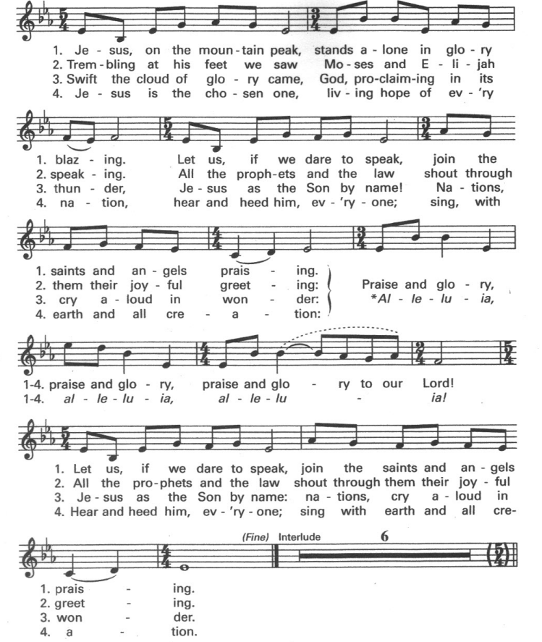
Reflection:
The Transfiguration of Christ is without doubt a momentous moment in Jesus’ life as well as being a most important event on the journey to the cross and a divine intervention for all of us who follow Him.
To begin with let’s consider this momentous moment in Jesus’ life on earth. At the start of His ministry, when He was baptised by John the Baptist, God spoke to Jesus and confirmed His divinity, revealed Him as His Son; God acknowledged how pleased He was with Him and anointed Him with the Holy Spirit. This event was recorded in all four of the Gospels. The only other time in Jesus’ ministry that God’s voice is heard is at the Transfiguration, when once again God acknowledges who Christ is, that He is His son and that He is loved by God. It is of great significance that at this moment God should say “Listen to Him”. Why is it so important that God should say this? Well, this links to our first reading in Deuteronomy as do the words of Jesus in John 12: 49-50 when He says: “ For I did not speak on my own, but the Father who sent me commanded me to say all that I have spoken. ⁵⁰ I know that his command leads to eternal life. So, whatever I say is just what the Father has told me to say.” This is why God says “Listen to Him” because in listening to Jesus we are listening to what God wants us to hear and because this confirms Him as the Messiah, spoken about by Moses. This event is also found in all four Gospels although in John it is the moment of majesty that is recorded when he writes in chapter 1 verse 14 “The Word became flesh and made his dwelling among us. We have seen his glory, the glory of the one and only Son, who came from the Father, full of grace and truth” rather than the re-telling of the whole event he witnessed. This incredible event in Jesus’ life is also momentous because it is miraculous- it is a miracle performed on Himself- that His glorious, supernatural divinity should be displayed in His physical earthly form. It leaves no doubt that Jesus’ authority is from God.
This is why the timing of this event on the journey to the cross is so crucial. It is about a week after Jesus spoke about His imminent death with His disciples. A revelation which caused them great consternation. Prior to this they had finally been coming to terms with who Jesus really was, indeed as we read in Matthew 16:16 Simon Peter answers “You are the Messiah, the Son of the living God.” Jesus then goes on to tell them that He will be killed. This enrages Peter-this is not what they were expecting or hoping for from their Messiah. Understandably their world was shaken, they did not understand what Jesus was saying to them, they were afraid that this man they had given everything up for and risked everything for was not who they thought. Their faith in Him was faltering. This is why the Transfiguration was an event of such consequence. It was necessary to reinforce the staggering faith of the apostles of those he chose to witness it. And there is no doubt that it worked, that those in His inner circle understood, were sure who He was. Indeed, Peter writes in 2 Peter 1: 16-18: “we were eyewitnesses of his majesty. ¹⁷ He received honour and glory from God the Father when the voice came to him from the Majestic Glory, saying, “This is my Son, whom I love; with him I am well pleased.” ¹⁸ We ourselves heard this voice that came from heaven when we were with him on the sacred mountain.” It was a sign that it would only be His humanity that would be crucified His Divinity would live on after death; it allowed those who witnessed what happened to understand that Jesus’ death would not be the end. It was the reassurance needed. It also represents a turning point in Jesus’ life and the journey to the cross, it was the peak of His public ministry- no longer would he continue his ministry in Galilee, his hour had come. Luke says, “Jesus resolutely set out for Jerusalem” (9:51) knowing fully what was to come.
It is of great magnitude that the prophets Moses and Elijah should appear at the Transfiguration for they represented the Law and the Prophets of the Jewish faith. Jesus’ authority is confirmed as he is seen with these great prophets - who by being able to speak with Jesus face to face perhaps finally see the face of God they were denied seeing in their lifetime encounters with God for as it says in Colossians 1:15 “The Son is the image of the invisible God.” The choice of these prophets is significant, for Jesus is the completion of the Law (represented by Moses) and the fulfilment of the prophecies of the Old Testament (represented by Elijah). He is the new covenant with God; He is their successor. Jesus took the Law and kept it perfectly, as the Prophets foretold, and brought the grace of God, which is apart from the Law. John wrote in chapter 1 verse 17 “¹⁷ For the law was given through Moses; grace and truth came through Jesus Christ.” It was Jesus who confirmed the greatest commandments in Law- “³⁷ ‘Love the Lord your God with all your heart and with all your soul and with all your mind.’³⁸ This is the first and greatest commandment. ³⁹ And the second is like it: ‘Love your neighbour as yourself.’⁴⁰ All the Law and the Prophets hang on these two commandments.” (Matthew 22:37-40). It perhaps also makes clear that Jesus is not Elijah as His disciples had reported some people said about Him!
The setting of the Transfiguration is also of great relevance. That this happens at the top of a mountain the place which is often a metaphor for the point where human nature meets God, where we can be closest to the heavens: the meeting place of the temporal and the eternal, with Jesus himself as the connecting point, acting as the bridge between heaven and earth, the bridge between us and God for Jesus Himself says: “I am the way and the truth and the life. No one comes to the Father except through me.”( John 14:6.) He is our intercessor with God as is told in Romans 8:34 “Christ Jesus who died—more than that, who was raised to life—is at the right hand of God and is also interceding for us.” So, it is fitting that this coming together of the earthly and divine form of Jesus should happen where it does, bringing together man and God.
So, what are the implications of the Transfiguration of Christ for us in our lives today? Well firstly it is an experience we are all invited to! This event on the Mountain was meant to strengthen the faith of these three disciples which had been shaken and which, in the days to come, would be tried and tested; Jesus wanted to encourage them just as He wants to encourage us on our faith journeys today it is a divine intervention for us all. There are times when our faith is shaken, for whatever reason, and perhaps revisiting this amazing event will help us to remember anew just who Christ is, what He did for us and what He will do for us if we believe in Him and listen to Him. In our moments of doubt, when it might feel like God has forsaken us, we are shown the glimpse of glory of what is promised so that we must not lose heart. I also believe that as the presence of the prophets at the Transfiguration shows that the promises and prophecies were fulfilled in Jesus so we can be sure that the promises He has made to us will be fulfilled. Just as those disciples who witnessed this most wondrous sight saw who He was - and who they would become in Him so should we. Knowing who Christ is; knowing His glory forever changed the way the disciples viewed themselves, their daily lives and their mission, after He would return to the Father so it should do the same for us today. We must live out His covenant; we must shine with His light; we must listen to Him as God Himself commanded. And so I close with some of the words from John Wesley’s hymn: “Christ whose glory fills the skies; Christ, the true, the only light, daystar in my heart appear; visit, then, this soul of mine; pierce the gloom of sin and grief; fill me, radiancy divine; scatter all my unbelief;” and I ask that we might all be filled with His radiancy divine and we may reflect it out into the world in all we think, say and do to His glory in His name. Amen.
Let us now spend time reflecting on His word and consider our own responses as we prepare to be sent out refreshed by His glory and His Spirit as we listen to our next song. Transfiguration by Hillsong Worship.
Song: Transfiguration by Hillsong Worship
From the cloud You speak
What was veiled now is seen
Jesus the image of
The invisible God
Divinity confirmed
In the transfigured Word
A kingdom once concealed
On the earth now revealed
Holy is the Lord revealed before my eyes
And my burning heart
Can scarcely take it in
As I behold Your beauty with unworthy eyes
The only song my soul can find to sing
Is hallelujah
Hallelujah
Hallelujah my King
Lead my longing heart
To the high ground
To a clear view
And in awe I'll be there
Beholding You

Holy is the Lord revealed before my eyes
And my burning heart can scarcely take it in
As I behold Your beauty with unworthy eyes
The only song my soul can find to sing
Is hallelujah
Hallelujah
Hallelujah my King
Hallelujah
Hallelujah
Hallelujah my King
Now I know, I have seen
Your glory that cannot be unseen
I am changed, and changing still
As I look upon You Lord and believe
Holy is the Lord revealed before my eyes
And my burning heart can scarcely take it in
As I behold Your beauty with unworthy eyes
The only song my soul can find to sing is
Hallelujah
Hallelujah
Hallelujah my King (repeat 3 more times)

Prayers of Intercession- Debbie
We now come to our prayers of intercession. After each prayer focus please join in with the words: “Hear our prayers Lord, in all Your heavenly glory we turn to you.”
Dear Lord, we come to You in prayer, thanking You for sharing Your glory with us.
We pray for our precious world, asking that Your Kingdom in all its glory, concealed by the sin and destruction of mankind, be once again revealed in all its intended glory. Help us to continue to seek and embrace the solutions to the problems that our ailing planet is facing. Help each one of us to play our part in protecting and taking care of the beautiful creation you gifted us to be stewards of.
“Hear our prayers Lord, in all Your heavenly glory we turn to you.”
We pray that Your glory might shine on the governments and religious leaders of our world inspiring them to work together for the good of all mankind, to realise the world You intended where all nations are flooded with Your grace and mercy. We pray that they will be guided by Your light to ensure we have a world that is at peace and that is fair and just for all. We pray particularly at this time that the governments of the world will listen to the people they serve and ensure that all nations have the capacity to recover both medically and economically from the global pandemic we are still experiencing which has infected over 109 million people and caused over 2.4 million deaths worldwide.
“Hear our prayers Lord, in all Your heavenly glory we turn to you.”
We pray for the Church across the world and ask that it reflects Your glory in all that it does. We pray that our churches will be beacons of light reaching outwards; shining with Your light; penetrating the darkness of the world to share Your message of hope and glory with those waiting to hear the good news of the Gospel. We pray especially for all Christians who are persecuted for their faith- who share our faith but not our freedom. Give them the strength and peace of Your glory Lord as they bear their cross in Your name with unwavering faith.
“Hear our prayers Lord, in all Your heavenly glory we turn to you.”
We pray for all those in need and marginalised by society and ask that Your glory might shine upon them now as it did when you walked the earth amongst us. We especially remember those affected by war; those living in poverty; those who are victims of trafficking and abuse; those who are refugees, who find themselves displaced and those experiencing homelessness. Help us all to do more to welcome those in need into our lives and do more to listen to them so we might be better able to help them and petition on their behalf so that all people across the world would have their basic human rights met.
“Hear our prayers Lord, in all Your heavenly glory we turn to you.”
We pray for all those who are sick and give thanks for those caring for them. We pray also for the bereaved and ask that You will comfort them and give them peace and hope that they discover solace in Your gift of everlasting life glimpsed in the glory of Your Transfiguration. We take a moment of silence to think about those we know personally who are ill or bereaved.
“Hear our prayers Lord, in all Your heavenly glory we turn to you.”
We offer all these prayers Lord and those in our hearts in the name of our great intercessor, Your son, Jesus Christ, the one who comes in glory, the ruler of all. AMEN.

We will now sing our final hymn; Shine Jesus Shine and ask that as we sing you will fill us with your light and glory and that we will be refreshed by Your Holy Spirit as we come to the end of our worship ready to be sent forth into the world and shine with hearts set on fire with Your love.
Song- Shine Jesus Shine
Lord, the light of your love is shining
In the midst of the darkness, shining
Jesus, Light of the world, shine upon us
Set us free by the truth you now bring us
Shine on me, shine on me
CHORUS:
Shine, Jesus, shine
Fill this land with the Father's glory
Blaze, Spirit, blaze
Set our hearts on fire
Flow, river, flow
Flood the nations with grace and mercy
Send forth your word
Lord, and let there be light

Lord, I come to your awesome presence
From the shadows into your radiance
By the blood I may enter your brightness
Search me, try me, consume all my darkness
Shine on me, shine on me
CHORUS
As we gaze on your kingly brightness
So our faces display your likeness
Ever changing from glory to glory
Mirrored here may our lives tell your story
Shine on me, shine on me
CHORUS

Blessing-
May the glory and grace of our Lord Jesus Christ, the love of God and the fellowship of the Holy Spirit be with us all, evermore. Amen.

